Trend Application - End-to-End DevSecOps CI/CD Pipeline

  - 1. Project Overview
The objective of this project was to design and implement an end-to-end DevSecOps CI/CD pipeline for deploying a React-based web application on Kubernetes running in AWS.
The project covers the complete software delivery lifecycle, including infrastructure provisioning, containerization, continuous integration, continuous deployment, monitoring, and autoscaling.

  - 2. Project Architecture
Developer → GitHub → Jenkins CI → Docker Hub → Jenkins CD → Kubernetes → Prometheus → Grafana

  - 3. Technologies Used
Category | Technology
Cloud | AWS
Infrastructure | Terraform
Source Control | Git, GitHub
CI/CD | Jenkins
Containerization | Docker
Registry | Docker Hub
Orchestration | Kubernetes (Amazon EKS)
Package Manager | Helm
Monitoring | Prometheus
Dashboard | Grafana
Security Scan | Trivy
Scripting | Bash

  - 4. Project Workflow
The project was implemented in the following phases.
Phase 1 – Source Code Management
The React application source code was pushed to a GitHub repository.
Git branching strategy was followed by implementing changes in the develop branch before merging into the main branch.
Activities
- Created Git repository
- Created develop branch
- Managed source code using Git
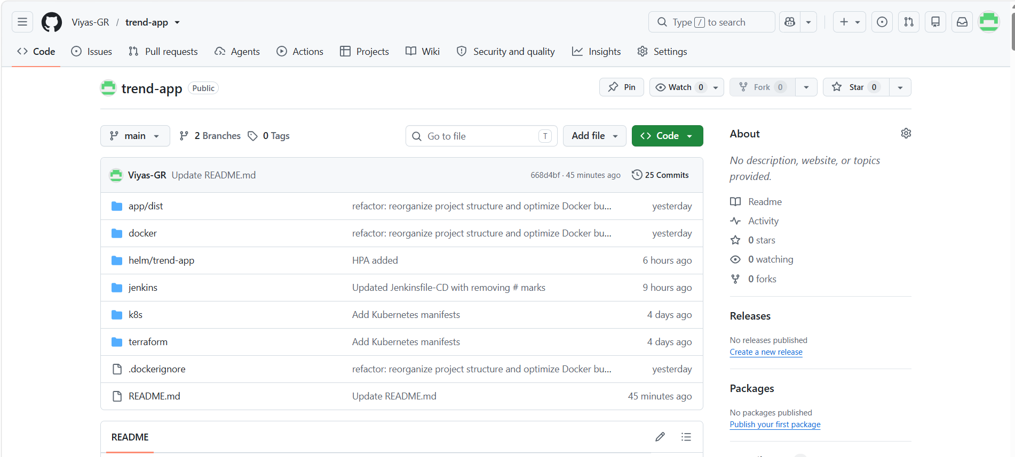

Phase 2 – Dockerization
The React application was containerized using Docker.
A lightweight NGINX image was used to serve the production build files.
Activities
- Created Dockerfile
- Built Docker image
- Tested locally
- Verified application accessibility

Phase 3 – Docker Hub
The Docker image was pushed to Docker Hub.
Each build was versioned using image tags.
Activities
- Created Docker Hub repository
- Pushed versioned images
- Maintained image versions
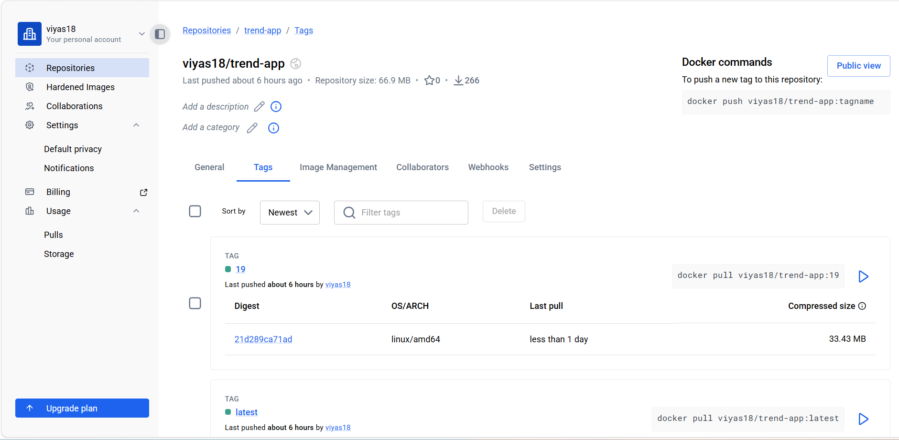

Phase 4 – Infrastructure Provisioning
Terraform was used to provision the required AWS infrastructure.
Resources Created
- VPC
- Security Groups
- EC2 Instance
- IAM Configuration
- Networking Components
Terraform configuration was organized into separate files for better maintainability.
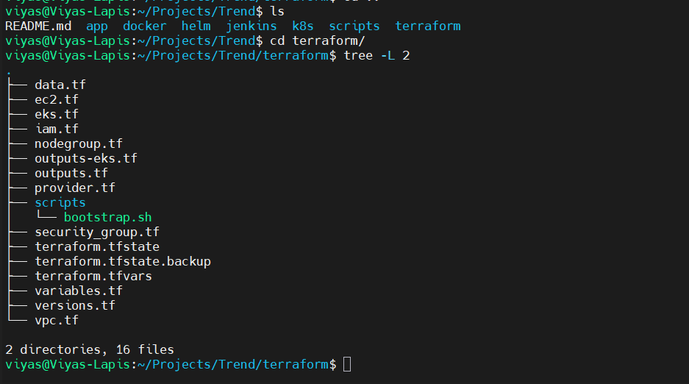

Phase 5 – Jenkins Setup
Jenkins was installed on the EC2 instance.
Required plugins were installed and Docker access was configured.
Activities
- Jenkins Installation
- Docker Configuration
- Plugin Installation
- Credentials Configuration
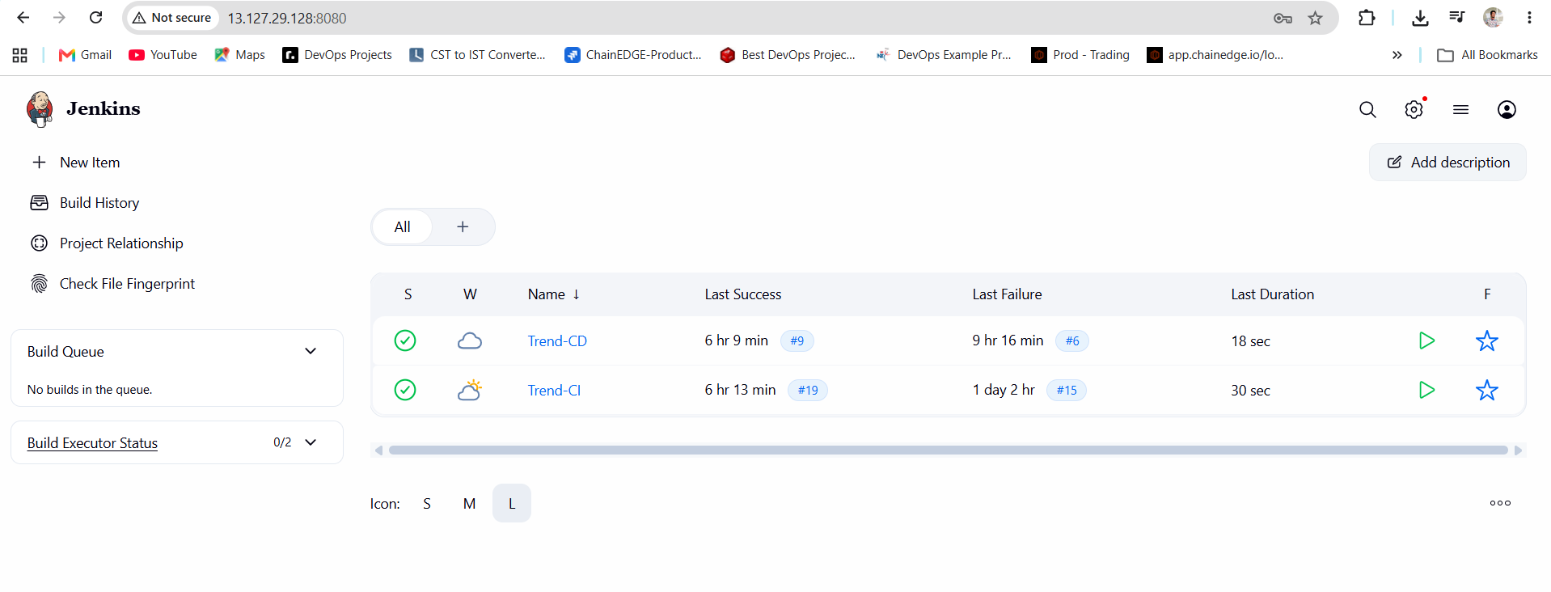
Phase 6 – Continuous Integration (CI)
A Jenkins CI pipeline was created to automate the build process.
The pipeline is triggered automatically using GitHub Webhooks whenever code is pushed.
CI Pipeline Stages
Workspace Cleanup
Removes previous build files to ensure a clean workspace.
Source Code Checkout
Downloads the latest source code from GitHub.
Environment Validation
Verifies Docker, Git, and required dependencies.
Docker Image Build
Builds a Docker image from the application source code.
Trivy Security Scan
Scans the Docker image for vulnerabilities.
Push Docker Image
Publishes the Docker image to Docker Hub.
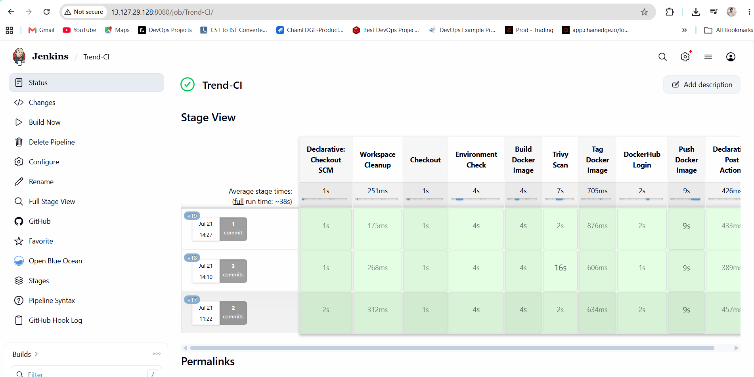

Phase 7 – Continuous Deployment (CD)
A separate Jenkins CD pipeline was created to deploy the application.
The deployment pipeline accepts an image tag and deploys that specific version.
CD Pipeline Stages
Workspace Cleanup
Prepares a clean deployment workspace.
Checkout Deployment Files
Downloads Helm charts and Kubernetes deployment files.
Environment Validation
Validates Kubernetes cluster connectivity.
Helm Deployment
Deploys the application using Helm.
Rollout Verification
Ensures the deployment completes successfully
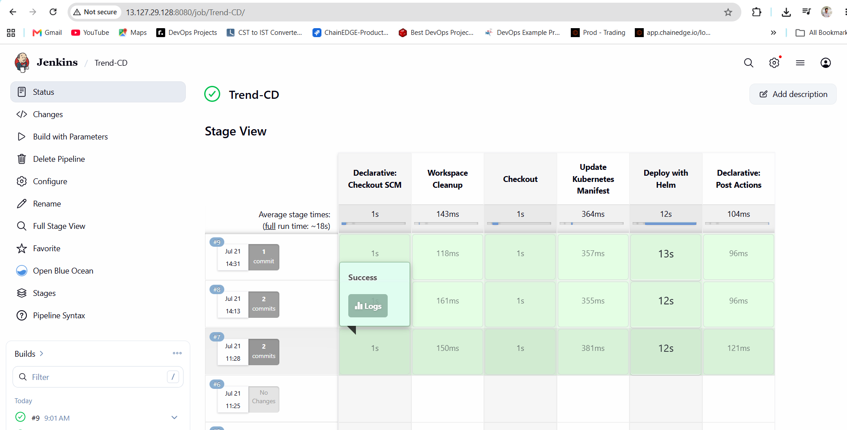

Phase 8 – Kubernetes Deployment
The application was deployed into Amazon EKS.
Kubernetes Resources
- Namespace
- Deployment
- ReplicaSet
- Pods
- LoadBalancer Service
Rolling updates were used during deployments
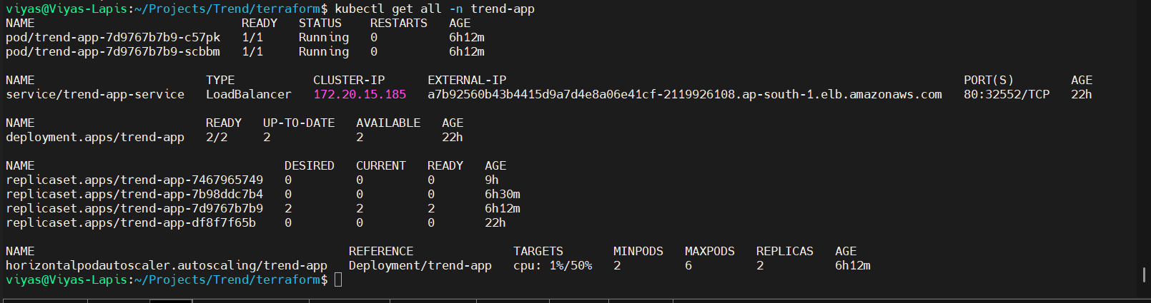

Phase 9 – Helm
Helm was used as the Kubernetes package manager.
Instead of managing multiple YAML files individually, all Kubernetes resources were packaged into a Helm chart.
Activities
- Created Helm Chart
- Parameterized values
- Used Helm Upgrade for deployments
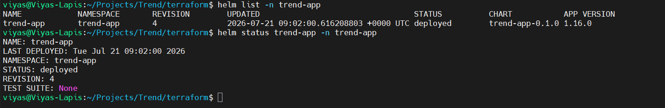
Phase 10 – Monitoring
Prometheus was configured to collect Kubernetes metrics.
Grafana dashboards were used to visualize cluster health.
Metrics Monitored
- CPU Usage
- Memory Usage
- Pod Metrics
- Node Metrics
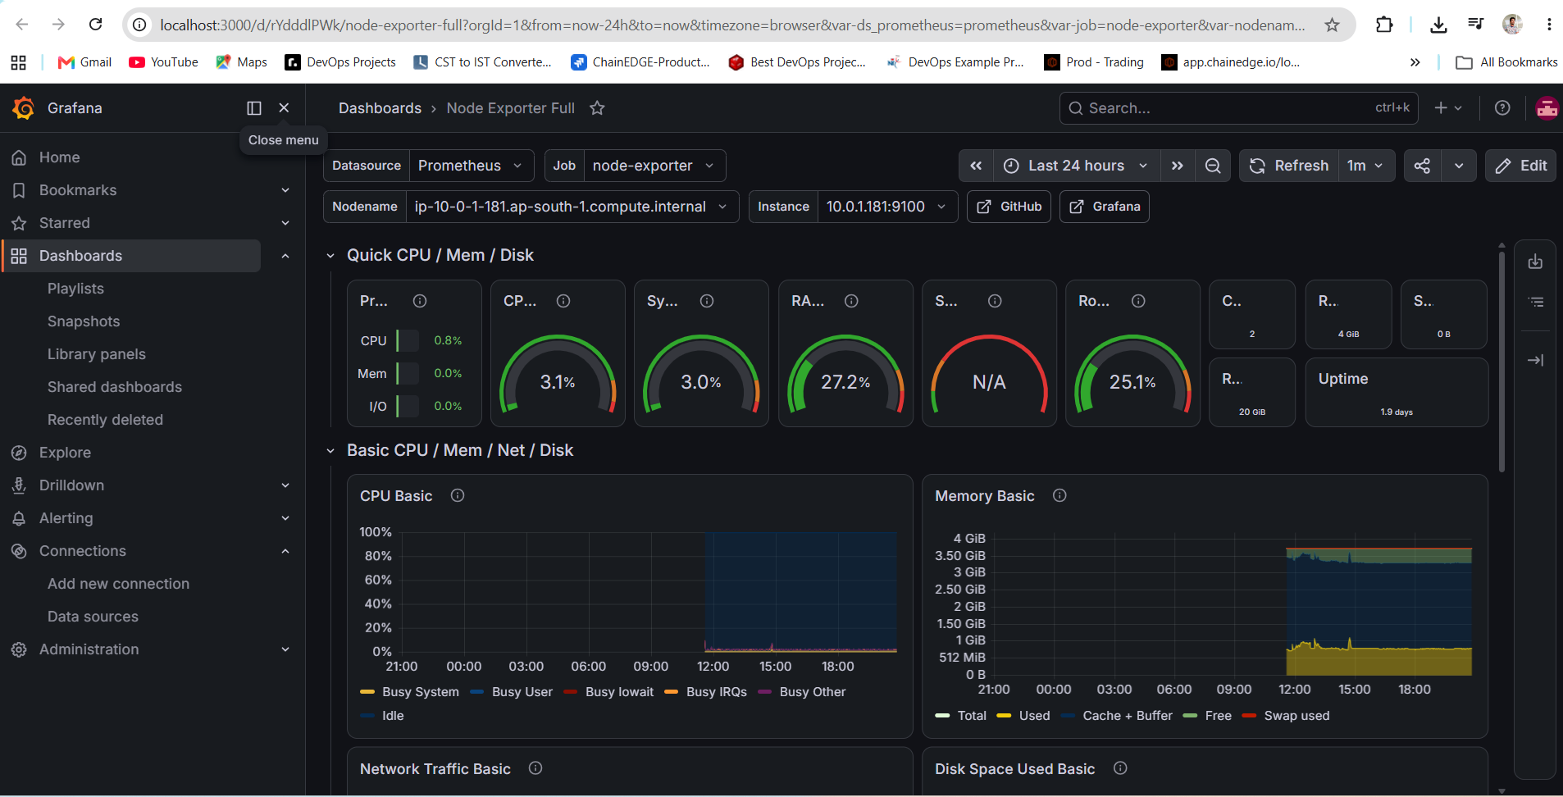

Phase 11 – Horizontal Pod Autoscaler (HPA)
Horizontal Pod Autoscaler was configured based on CPU utilization.
Configuration:
- Minimum Replicas : 2
- Maximum Replicas : 6
- Target CPU : 50%
Resource Requests and Limits were configured to enable autoscaling.
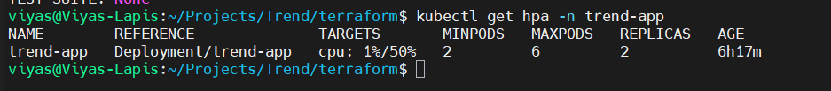

Phase 12 – Security
Security scanning was integrated into the CI pipeline using Trivy.
The Docker image was scanned before publishing.
Scan Includes
- Critical Vulnerabilities
- High Vulnerabilities
- Operating System Packages
- Application Dependencies

Project Outcome
Successfully implemented an end-to-end DevSecOps pipeline capable of:
- Automated builds
- Security scanning
- Docker image versioning
- Continuous deployment
- Kubernetes orchestration
- Monitoring
- Autoscaling
The pipeline demonstrates a production-style software delivery workflow using modern DevOps tools and best practices.

